#MASS SPECIFIC ANALYSIS

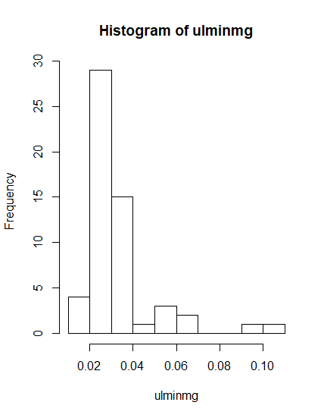

> summary(glmerint)

Generalized linear mixed model fit by maximum

likelihood (Laplace Approximation) [glmerMod]

Family: Gamma ( inverse )

Formula: ulminmg ~ Sex * Act + chamber + (batch | date)

AIC BIC logLik deviance df.resid

-356.0 -323.6 194.0 -388.0 40

Scaled residuals:

Min 1Q Median 3Q Max

-1.7499 -0.5785 -0.1317 0.3989 3.3125

Random effects:

Groups Name Variance Std.Dev. Corr

date (Intercept) 1.270e-09 3.563e-05

batchii 1.151e-04 1.073e-02 1.00

batchiii 9.307e-02 3.051e-01 0.66 0.66

batchiv 1.935e+01 4.399e+00 0.66 0.66 1.00

Residual 6.378e-02 2.526e-01

Number of obs: 56, groups: date, 2

Fixed effects:

Estimate Std. Error t value Pr(>|z|)

(Intercept) 30.928 3.757 8.232 < 2e-16 ***

SexM -9.069 3.221 -2.816 0.00487 **

Act -35.523 19.467 -1.825 0.06803 .

chamber 1.574 0.254 6.196 5.77e-10 ***

SexM:Act 22.103 19.385 1.140 0.25421

---

Signif. codes:

0 ‘***’ 0.001 ‘**’ 0.01 ‘*’ 0.05 ‘.’ 0.1 ‘ ’ 1

Correlation of Fixed Effects:

(Intr) SexM Act chambr

SexM -0.715

Act -0.771 0.761

chamber -0.519 0.042 0.155

SexM:Act 0.708 -0.802 -0.984 -0.075

convergence code: 0

boundary (singular) fit: see ?isSingular

> summary(glmer)

Generalized linear mixed model fit by maximum

likelihood (Laplace Approximation) [glmerMod]

Family: Gamma ( inverse )

Formula: ulminmg ~ Sex + Act + chamber + (batch | date)

AIC BIC logLik deviance df.resid

-356.8 -326.4 193.4 -386.8 41

Scaled residuals:

Min 1Q Median 3Q Max

-1.8142 -0.6488 -0.0029 0.3413 3.4567

Random effects:

Groups Name Variance Std.Dev. Corr

date (Intercept) 6.611e-04 0.02571

batchii 4.273e-03 0.06537 -1.00

batchiii 3.685e-02 0.19196 0.60 -0.60

batchiv 1.933e+01 4.39662 0.68 -0.68

Residual 6.524e-02 0.25542

0.99

Number of obs: 56, groups: date, 2

Fixed effects:

Estimate Std. Error t value Pr(>|z|)

(Intercept) 28.0263 2.7144 10.325 < 2e-16 ***

SexM -6.2239 1.9604 -3.175 0.0015 **

Act -13.6795 3.4748 -3.937 8.26e-05 ***

chamber 1.5926 0.2583 6.165 7.06e-10 ***

---

Signif. codes:

0 ‘***’ 0.001 ‘**’ 0.01 ‘*’ 0.05 ‘.’ 0.1 ‘ ’ 1

Correlation of Fixed Effects:

(Intr) SexM Act

SexM -0.355 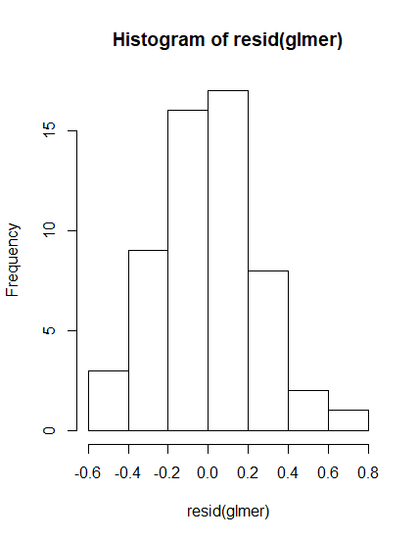

Act -0.588 -0.267

chamber -0.668 -0.022 0.467

convergence code: 0

boundary (singular) fit: see ?isSingular

> shapiro.test(resid(glmer))

Shapiro-Wilk normality test

data: resid(glmer)

W = 0.97711, p-value = 0.3627

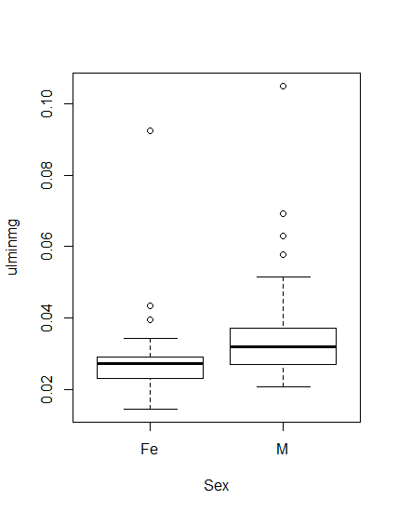

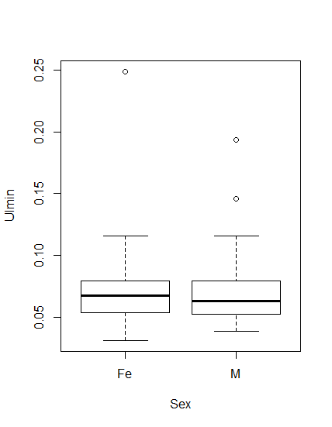

**# WHOLE ORGANISM BOTH MASS AND SEX START**

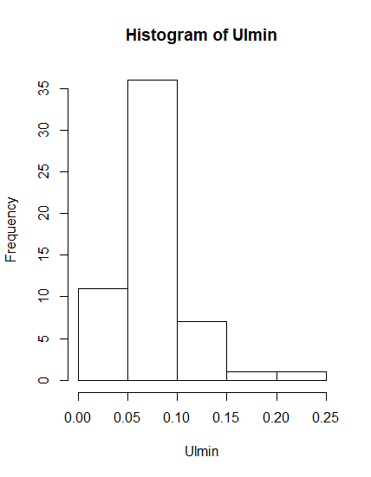

> summary(wglmerint)

Generalized linear mixed model fit by maximum

likelihood (Laplace Approximation) [glmerMod]

Family: Gamma ( inverse )

Formula:

Ulmin ~ Mass * Sex + Act + chamber + (batch | date)

AIC BIC logLik deviance df.resid

-268.0 -233.5 151.0 -302.0 39

Scaled residuals:

Min 1Q Median 3Q Max

-1.69767 -0.62400 -0.01215 0.55014 2.88864

Random effects:

Groups Name Variance Std.Dev. Corr

date (Intercept) 0.53376 0.7306

batchii 1.67571 1.2945 -1.00

batchiii 0.23454 0.4843 -0.95 0.95

batchiv 1.49005 1.2207 0.70 -0.70 -0.45

Residual 0.05971 0.2444

Number of obs: 56, groups: date, 2

Fixed effects:

Estimate Std. Error t value Pr(>|z|)

(Intercept) 29.0156 5.7606 5.037 4.73e-07 ***

Mass -6.8389 2.2401 -3.053 0.00227 **

SexM -5.5521 9.3517 -0.594 0.55271

Act -8.9691 2.0890 -4.294 1.76e-05 ***

chamber 0.6988 0.1109 6.303 2.91e-10 ***

Mass:SexM 1.0343 4.4661 0.232 0.81686

---

Signif. codes:

0 ‘***’ 0.001 ‘**’ 0.01 ‘*’ 0.05 ‘.’ 0.1 ‘ ’ 1

Correlation of Fixed Effects:

(Intr) Mass SexM Act chambr

Mass -0.954

SexM -0.405 0.351

Act 0.057 -0.179 -0.159

chamber -0.121 -0.021 0.111 0.388

Mass:SexM 0.273 -0.214 -0.985 0.115 -0.129

convergence code: 0

boundary (singular) fit: see ?isSingular

> anova(wglmerint,wglmer)

Data: NULL

Models:

wglmer: Ulmin ~ Mass + Sex + Act + chamber + (batch | date)

wglmerint: Ulmin ~ Mass * Sex + Act + chamber + (batch | date)

Df AIC BIC logLik deviance Chisq

wglmer 16 -269.92 -237.52 150.96 -301.92

wglmerint 17 -267.98 -233.55 150.99 -301.98 0.0541

Chi Df Pr(>Chisq)

wglmer

wglmerint 1 0.8161

> summary(wglmer)

Generalized linear mixed model fit by maximum

likelihood (Laplace Approximation) [glmerMod]

Family: Gamma ( inverse )

Formula:

Ulmin ~ Mass + Sex + Act + chamber + (batch | date)

AIC BIC logLik deviance df.resid

-269.9 -237.5 151.0 -301.9 40

Scaled residuals:

Min 1Q Median 3Q Max

-1.70607 -0.58340 -0.00582 0.49581 2.91595

Random effects:

Groups Name Variance Std.Dev. Corr

date (Intercept) 0.5240 0.7239

batchii 1.6047 1.2668 -1.00

batchiii 0.1932 0.4396 -1.00 1.00

batchiv 1.1115 1.0543 1.00 -1.00 -1.00

Residual 0.0602 0.2454

Number of obs: 56, groups: date, 2

Fixed effects:

Estimate Std. Error t value Pr(>|z|)

(Intercept) 28.6552 5.5363 5.176 2.27e-07 ***

Mass -6.7324 2.1866 -3.079 0.00208 **

SexM -3.4197 1.5815 -2.162 0.03060 *

Act -9.0206 2.0815 -4.334 1.47e-05 ***

chamber 0.7022 0.1102 6.374 1.85e-10 ***

---

Signif. codes:

0 ‘***’ 0.001 ‘**’ 0.01 ‘*’ 0.05 ‘.’ 0.1 ‘ ’ 1

Correlation of Fixed Effects:

(Intr) Mass SexM Act

Mass -0.957

SexM -0.835 0.845

Act 0.034 -0.160 -0.267

chamber -0.088 -0.051 -0.092 0.409

convergence code: 0

boundary (singular) fit: see ?isSingular

#LOOK AT THAT COLINEARITY

> shapiro.test(resid(wglmer))

Shapiro-Wilk normality test

data: resid(wglmer)

W = 0.98739, p-value = 0.8234

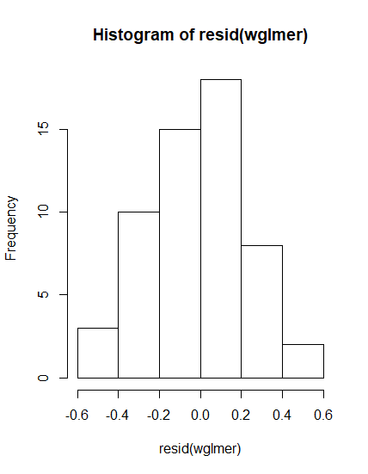

#WHOLE ORGANISM METABOLIC RATE MASS MODELS OR SEX MODELS

> glmer(Ulmin*100~Sex+Act+chamber+(batch|date),family=Gamma)->wsexglmer

> summary(wsexglmer)

Generalized linear mixed model fit by maximum

likelihood (Laplace Approximation) [glmerMod]

Family: Gamma ( log )

Formula: Ulmin ~ Sex + Act + chamber + (batch | date)

AIC BIC logLik deviance df.resid

-254.6 -224.3 142.3 -284.6 41

Scaled residuals:

Min 1Q Median 3Q Max

-1.3974 -0.6986 -0.1426 0.5986 3.6084

Random effects:

Groups Name Variance Std.Dev. Corr

date (Intercept) 0.000000 0.00000

batchii 0.016644 0.12901 NaN

batchiii 0.006858 0.08281 NaN 0.48

batchiv 0.058197 0.24124 NaN 0.48 1.00

Residual 0.087999 0.29665

Number of obs: 56, groups: date, 2

Fixed effects:

Estimate Std. Error t value Pr(>|z|)

(Intercept) -2.654527 0.122053 -21.749 < 2e-16 ***

SexM -0.017558 0.071897 -0.244 0.80706

Act 0.963986 0.264630 3.643 0.00027 ***

chamber -0.043116 0.008818 -4.890 1.01e-06 ***

---

Signif. codes:

0 ‘***’ 0.001 ‘**’ 0.01 ‘*’ 0.05 ‘.’ 0.1 ‘ ’ 1

Correlation of Fixed Effects:

(Intr) SexM Act

SexM -0.315

Act -0.488 -0.047

chamber -0.616 -0.035 0.272

convergence code: 0

boundary (singular) fit: see ?isSingular

> summary(wsexglmernosex)

Generalized linear mixed model fit by maximum

likelihood (Laplace Approximation) [glmerMod]

Family: Gamma ( inverse )

Formula: Ulmin * 100 ~ Act + chamber + (batch | date)

AIC BIC logLik deviance df.resid

251.7 280.0 -111.8 223.7 42

Scaled residuals:

Min 1Q Median 3Q Max

-1.46278 -0.74071 0.02561 0.57899 2.52208

Random effects:

Groups Name Variance Std.Dev. Corr

date (Intercept) 0.0000000 0.00000

batchii 0.0003574 0.01890 NaN

batchiii 0.0001426 0.01194 NaN 0.99

batchiv 0.0008948 0.02991 NaN 0.99 1.00

Residual 0.0749453 0.27376

Number of obs: 56, groups: date, 2

Fixed effects:

Estimate Std. Error t value Pr(>|z|)

(Intercept) 0.141924 0.017401 8.156 3.46e-16 ***

Act -0.094940 0.021219 -4.474 7.66e-06 ***

chamber 0.006954 0.001188 5.854 4.81e-09 ***

---

Signif. codes:

0 ‘***’ 0.001 ‘**’ 0.01 ‘*’ 0.05 ‘.’ 0.1 ‘ ’ 1

Correlation of Fixed Effects:

(Intr) Act

Act -0.810

chamber -0.538 0.389

convergence code: 0

boundary (singular) fit: see ?isSingular

> shapiro.test(resid(wsexglmernosex))

Shapiro-Wilk normality test

data: resid(wsexglmernosex)

W = 0.97634, p-value = 0.3364

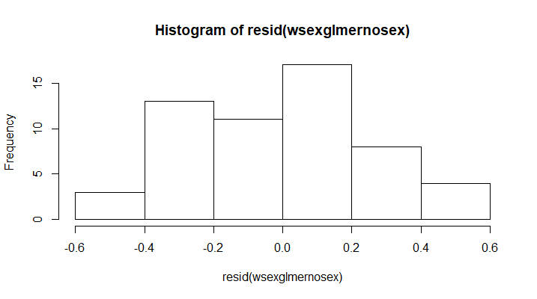

Considered some models with only batch and only date as random effects

> summary(wsglmernodate)

Generalized linear mixed model fit by maximum likelihood (Laplace Approximation) ['glmerMod']

Family: Gamma ( inverse )

Formula: Ulmin * 60 ~ chamber + Sex + Act + (1 | batch)

AIC BIC logLik deviance df.resid

180.5 192.6 -84.2 168.5 50

Scaled residuals:

Min 1Q Median 3Q Max

-1.57070 -0.75866 -0.00834 0.61908 2.61515

Random effects:

Groups Name Variance Std.Dev.

batch (Intercept) 0.0008041 0.02836

Residual 0.0729532 0.27010

Number of obs: 56, groups: batch, 4

Fixed effects:

Estimate Std. Error t value Pr(>|z|)

(Intercept) 0.186880 0.032690 5.717 1.09e-08 ***

chamber 0.011514 0.001989 5.789 7.09e-09 ***

SexM 0.009239 0.015170 0.609 0.542

Act -0.164055 0.036030 -4.553 5.28e-06 ***

---

Signif. codes: 0 ‘***’ 0.001 ‘**’ 0.01 ‘*’ 0.05 ‘.’ 0.1 ‘ ’ 1

Correlation of Fixed Effects:

(Intr) chambr SexM

chamber -0.401

SexM -0.149 -0.081

Act -0.304 0.398 -0.276

> summary(wsglmernobatch)

Generalized linear mixed model fit by maximum likelihood (Laplace Approximation) ['glmerMod']

Family: Gamma ( inverse )

Formula: Ulmin * 60 ~ chamber + Sex + Act + (1 | date)

AIC BIC logLik deviance df.resid

192.0 204.1 -90.0 180.0 50

Scaled residuals:

Min 1Q Median 3Q Max

-1.602 -0.713 -0.157 0.624 3.455

Random effects:

Groups Name Variance Std.Dev.

date (Intercept) 0.0004726 0.02174

Residual 0.0892152 0.29869

Number of obs: 56, groups: date, 2

Fixed effects:

Estimate Std. Error t value Pr(>|z|)

(Intercept) 0.172147 0.035712 4.820 1.43e-06 ***

chamber 0.011971 0.002297 5.212 1.86e-07 ***

SexM 0.012099 0.017400 0.695 0.486842

Act -0.134772 0.035452 -3.802 0.000144 ***

---

Signif. codes: 0 ‘***’ 0.001 ‘**’ 0.01 ‘*’ 0.05 ‘.’ 0.1 ‘ ’ 1

Correlation of Fixed Effects:

(Intr) chambr SexM

chamber -0.424

SexM -0.167 -0.049

Act -0.304 0.424 -0.307

> summary(wmassglmer)

Generalized linear mixed model fit by maximum

likelihood (Laplace Approximation) [glmerMod]

Family: Gamma ( inverse )

Formula:

Ulmin * 1000 ~ Mass + Act + chamber + (batch | date)

AIC BIC logLik deviance df.resid

506.4 536.8 -238.2 476.4 41

Scaled residuals:

Min 1Q Median 3Q Max

-1.69276 -0.75874 -0.08994 0.71676 2.85274

Random effects:

Groups Name Variance Std.Dev. Corr

date (Intercept) 1.212e-06 0.001101

batchii 3.357e-06 0.001832 -1.00

batchiii 1.399e-06 0.001183 -0.90 0.90

batchiv 5.671e-06 0.002381 -0.41 0.41

Residual 6.515e-02 0.255246

0.76

Number of obs: 56, groups: date, 2

Fixed effects:

Estimate Std. Error t value Pr(>|z|)

(Intercept) 0.0187088 0.0035462 5.276 1.32e-07 ***

Mass -0.0027347 0.0012029 -2.273 0.023 *

Act -0.0102462 0.0020378 -5.028 4.96e-07 ***

chamber 0.0006819 0.0001108 6.152 7.64e-10 ***

---

Signif. codes:

0 ‘***’ 0.001 ‘**’ 0.01 ‘*’ 0.05 ‘.’ 0.1 ‘ ’ 1

Correlation of Fixed Effects:

(Intr) Mass Act

Mass -0.748

Act -0.310 0.138

chamber -0.257 0.053 0.374

convergence code: 0

boundary (singular) fit: see ?isSingular

> shapiro.test(resid(wmassglmer))

Shapiro-Wilk normality test

data: resid(wmassglmer)

W = 0.9871, p-value = 0.8108

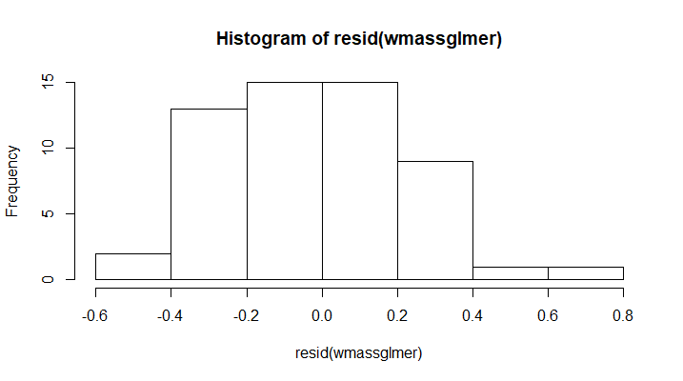

Removing extreme activity value row

> aggregate(Act~Sex, FUN=mean)

Sex Act

1 F 0.11259286

2 M 0.09798519

> aggregate(Act~Sex, FUN=sd)

Sex Act

1 F 0.06857459

2 M 0.07110236

# Fem N= 28, Male N=27

> summary(sexglmer)

Generalized linear mixed model fit by maximum likelihood (Laplace Approximation) ['glmerMod']

Family: Gamma ( inverse )

Formula: Ulmin * 60 ~ Sex + Act + chamber + (batch | date)

AIC BIC logLik deviance df.resid

192.1 222.2 -81.0 162.1 40

Scaled residuals:

Min 1Q Median 3Q Max

-1.48991 -0.71664 0.07946 0.66252 2.43454

Random effects:

Groups Name Variance Std.Dev. Corr

date (Intercept) 0.0000000 0.00000

batchii 0.0010271 0.03205 NaN

batchiii 0.0004241 0.02059 NaN 0.98

batchiv 0.0025173 0.05017 NaN 0.98 1.00

Residual 0.0752662 0.27435

Number of obs: 55, groups: date, 2

Fixed effects:

Estimate Std. Error t value Pr(>|z|)

(Intercept) 0.231731 0.030831 7.516 5.64e-14 ***

SexM 0.009420 0.015248 0.618 0.537

Act -0.141042 0.108030 -1.306 0.192

chamber 0.011535 0.002001 5.765 8.15e-09 ***

---

Signif. codes: 0 ‘***’ 0.001 ‘**’ 0.01 ‘*’ 0.05 ‘.’ 0.1 ‘ ’ 1

Correlation of Fixed Effects:

(Intr) SexM Act

SexM -0.168

Act -0.503 -0.008

chamber -0.516 -0.076 0.212

convergence code: 0

boundary (singular) fit: see ?isSingular

> glmer(Ulmin*60~Act+chamber+(batch|date),family=Gamma)->sexglmernosex

boundary (singular) fit: see ?isSingular

> summary(sexglmernosex)

Generalized linear mixed model fit by maximum likelihood (Laplace Approximation) ['glmerMod']

Family: Gamma ( inverse )

Formula: Ulmin * 60 ~ Act + chamber + (batch | date)

AIC BIC logLik deviance df.resid

190.5 218.6 -81.2 162.5 41

Scaled residuals:

Min 1Q Median 3Q Max

-1.45142 -0.74050 0.04189 0.56907 2.51702

Random effects:

Groups Name Variance Std.Dev. Corr

date (Intercept) 0.000000 0.00000

batchii 0.001020 0.03194 NaN

batchiii 0.000411 0.02027 NaN 0.98

batchiv 0.002537 0.05037 NaN 0.98 1.00

Residual 0.076366 0.27634

Number of obs: 55, groups: date, 2

Fixed effects:

Estimate Std. Error t value Pr(>|z|)

(Intercept) 0.234949 0.030386 7.732 1.06e-14 ***

Act -0.140405 0.107903 -1.301 0.193

chamber 0.011624 0.002009 5.786 7.20e-09 ***

---

Signif. codes: 0 ‘***’ 0.001 ‘**’ 0.01 ‘*’ 0.05 ‘.’ 0.1 ‘ ’ 1

Correlation of Fixed Effects:

(Intr) Act

Act -0.507

chamber -0.542 0.214

convergence code: 0

boundary (singular) fit: see ?isSingular

> summary(sexglmernosexnoact)

Generalized linear mixed model fit by maximum likelihood (Laplace Approximation) ['glmerMod']

Family: Gamma ( inverse )

Formula: Ulmin * 60 ~ chamber + (batch | date)

AIC BIC logLik deviance df.resid

190.1 216.2 -82.0 164.1 42

Scaled residuals:

Min 1Q Median 3Q Max

-1.4974 -0.7200 0.1396 0.5724 2.5980

Random effects:

Groups Name Variance Std.Dev. Corr

date (Intercept) 0.0000000 0.00000

batchii 0.0009900 0.03146 NaN

batchiii 0.0004119 0.02029 NaN 0.99

batchiv 0.0025565 0.05056 NaN 0.99 1.00

Residual 0.0775064 0.27840

Number of obs: 55, groups: date, 2

Fixed effects:

Estimate Std. Error t value Pr(>|z|)

(Intercept) 0.215323 0.026945 7.991 1.34e-15 ***

chamber 0.012177 0.002019 6.032 1.62e-09 ***

---

Signif. codes: 0 ‘***’ 0.001 ‘**’ 0.01 ‘*’ 0.05 ‘.’ 0.1 ‘ ’ 1

Correlation of Fixed Effects:

(Intr)

chamber -0.529

convergence code: 0

boundary (singular) fit: see ?isSingular

> shapiro.test(resid(sexglmernosexnoact))

Shapiro-Wilk normality test

data: resid(sexglmernosexnoact)

W = 0.97603, p-value = 0.3379

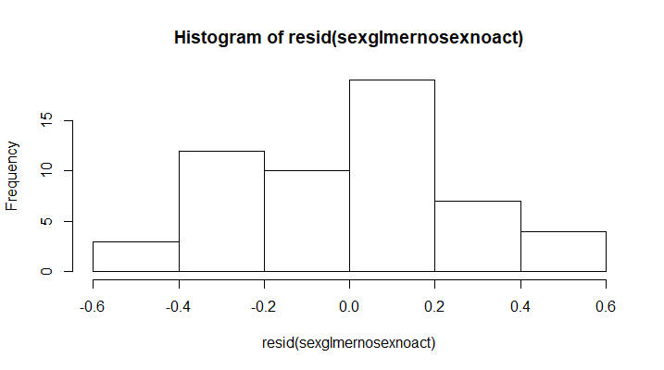

> summary(massglmer)

Generalized linear mixed model fit by maximum likelihood (Laplace Approximation) ['glmerMod']

Family: Gamma ( inverse )

Formula: Ulmin * 60 ~ Mass + Act + chamber + (batch | date)

AIC BIC logLik deviance df.resid

187.9 218.0 -79.0 157.9 40

Scaled residuals:

Min 1Q Median 3Q Max

-1.62948 -0.68269 -0.08184 0.78404 2.83746

Random effects:

Groups Name Variance Std.Dev. Corr

date (Intercept) 0.0000000 0.00000

batchii 0.0006578 0.02565 NaN

batchiii 0.0002701 0.01643 NaN 1.00

batchiv 0.0017915 0.04233 NaN 1.00 1.00

Residual 0.0688050 0.26231

Number of obs: 55, groups: date, 2

Fixed effects:

Estimate Std. Error t value Pr(>|z|)

(Intercept) 0.331378 0.053173 6.232 4.60e-10 ***

Mass -0.046060 0.021163 -2.176 0.0295 *

Act -0.166147 0.107028 -1.552 0.1206

chamber 0.011374 0.001909 5.957 2.57e-09 ***

---

Signif. codes: 0 ‘***’ 0.001 ‘**’ 0.01 ‘*’ 0.05 ‘.’ 0.1 ‘ ’ 1

Correlation of Fixed Effects:

(Intr) Mass Act

Mass -0.826

Act -0.365 0.108

chamber -0.350 0.065 0.196

convergence code: 0

boundary (singular) fit: see ?isSingular

> summary(massglmernoact)

Generalized linear mixed model fit by maximum likelihood (Laplace Approximation) ['glmerMod']

Family: Gamma ( inverse )

Formula: Ulmin * 1000 ~ Mass + chamber + (batch | date)

AIC BIC logLik deviance df.resid

496.9 525.0 -234.4 468.9 41

Scaled residuals:

Min 1Q Median 3Q Max

-1.74798 -0.71929 0.01474 0.59574 2.49168

Random effects:

Groups Name Variance Std.Dev. Corr

date (Intercept) 2.601e-06 0.001613

batchii 3.889e-06 0.001972 -1.00

batchiii 2.187e-06 0.001479 -0.98 0.98

batchiv 3.447e-06 0.001857 -0.29 0.29 0.47

Residual 6.685e-02 0.258560

Number of obs: 55, groups: date, 2

Fixed effects:

Estimate Std. Error t value Pr(>|z|)

(Intercept) 0.0165117 0.0040737 4.053 5.05e-05 ***

Mass -0.0025698 0.0012778 -2.011 0.0443 *

chamber 0.0007161 0.0001150 6.226 4.79e-10 ***

---

Signif. codes: 0 ‘***’ 0.001 ‘**’ 0.01 ‘*’ 0.05 ‘.’ 0.1 ‘ ’ 1

Correlation of Fixed Effects:

(Intr) Mass

Mass -0.752

chamber -0.202 0.060

convergence code: 0

boundary (singular) fit: see ?isSingular

> shapiro.test(resid(massglmernoact)

+ )

Shapiro-Wilk normality test

data: resid(massglmernoact)

W = 0.98889, p-value = 0.8909

